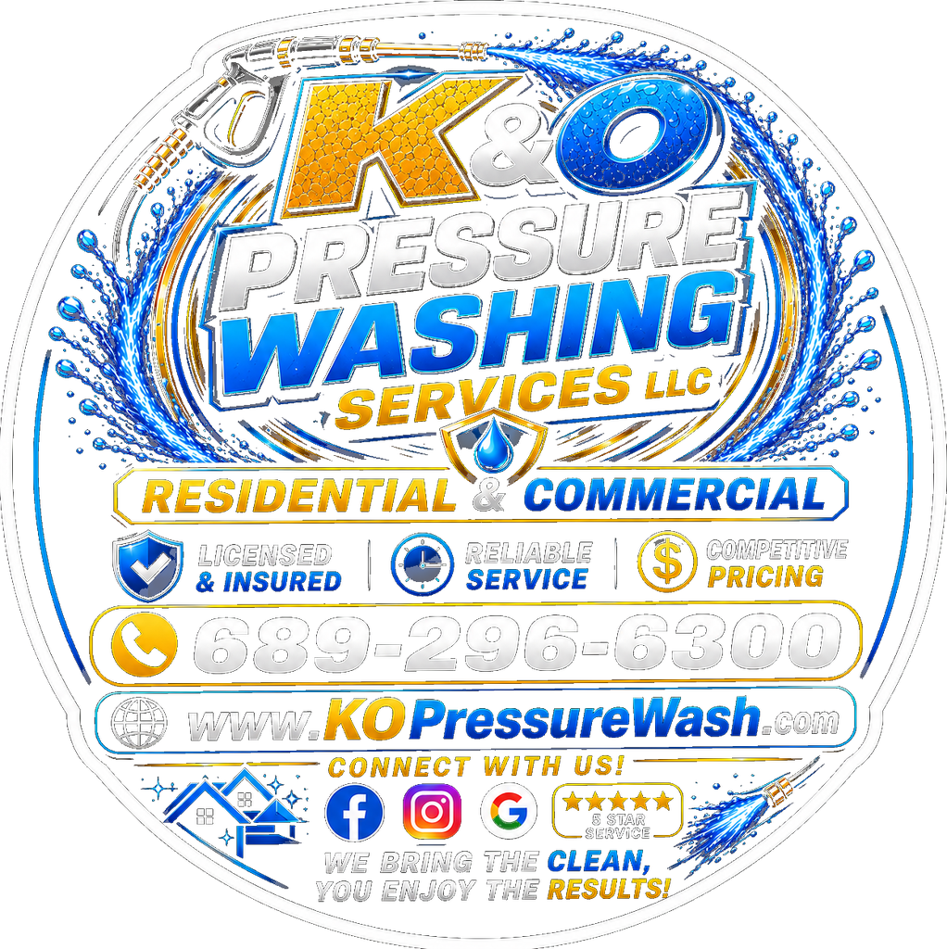
K&O Pressure Washing Services LLC
Licensed & Insured Exterior Cleaning | St. Cloud, Florida | Serving Central Florida
COMPANY OVERVIEW
K&O Pressure Washing Services LLC is a licensed and insured exterior cleaning company based in St. Cloud, Florida, serving residential, commercial, and industrial clients throughout Central Florida. Our mission is to provide professional, reliable, and cost effective exterior cleaning solutions that enhance curb appeal, protect property investments, and deliver lasting results. We utilize state of the art pressure washing equipment, eco friendly cleaning agents, and proven techniques to safely remove dirt, mold, mildew, algae, rust, and stains from a wide range of surfaces.
CORE CAPABILITIES
• High and low pressure surface cleaning for driveways, sidewalks, patios, and pool decks
• Soft wash and power wash services for residential and commercial building exteriors
• Roof cleaning and treatment to eliminate algae, moss, and black streaks
• Fence and deck washing and restoration for wood, vinyl, and composite materials
• Concrete cleaning, stain removal, and sealing to protect and extend surface life
• Gutter cleaning, brightening, and exterior washing for complete home maintenance
• Rust removal and oxidation treatment for driveways, siding, and concrete surfaces
• Commercial storefront, parking lot, and industrial equipment pressure washing
• Fleet and heavy equipment washing for trucks, machinery, and construction vehicles
• Window cleaning and exterior glass restoration for residential and commercial properties
• New construction cleanup and post renovation pressure washing services
• Eco friendly and biodegradable cleaning solutions safe for landscaping and pets
WHAT SETS US APART
• Fully licensed and insured for residential, commercial, and industrial projects
• Family owned and operated with a commitment to personalized customer service
• Advanced equipment and surface appropriate techniques for every job type
• Eco conscious cleaning products that are safe for plants, pets, and the environment
• Flexible scheduling with prompt, on time service and clear communication
• Competitive pricing with free estimates and no hidden fees
• Satisfaction guaranteed with attention to detail on every project
• Experienced in working with homeowners, property managers, real estate professionals, and contractors
INDUSTRIES SERVED
• Residential Properties | • Commercial Buildings | • Retail & Storefronts
• Property Management | • Real Estate & Home Sales | • HOA Communities
• Industrial Facilities | • Construction Sites | • Fleet & Vehicle Operations
COMPANY INFORMATION
Legal Name: | K&O Pressure Washing Services LLC
DBA: | K&O Pressure Washing
Business Type: | Limited Liability Company (LLC)
Location: | St. Cloud, Florida
Service Area: | Central Florida including Kissimmee, Orlando, St. Cloud, Davenport, and surrounding communities
Email: | kopressurewashfl@gmail.com
Phone: | (689) 296-6300
Website: | kopressurewash.com
NAICS CODES
Code | Description
561740 | Carpet and Upholstery Cleaning Services
561720 | Janitorial Services
561790 | Other Services to Buildings and Dwellings
WHY CHOOSE K&O PRESSURE WASHING SERVICES LLC?
At K&O Pressure Washing Services LLC, we believe every property deserves professional care and attention. We are committed to delivering dependable service, quality workmanship, and long lasting results through safe cleaning techniques and outstanding customer support. Our goal is to build lasting relationships by exceeding customer expectations on every project.
Professional. Reliable. Results You Can See.

